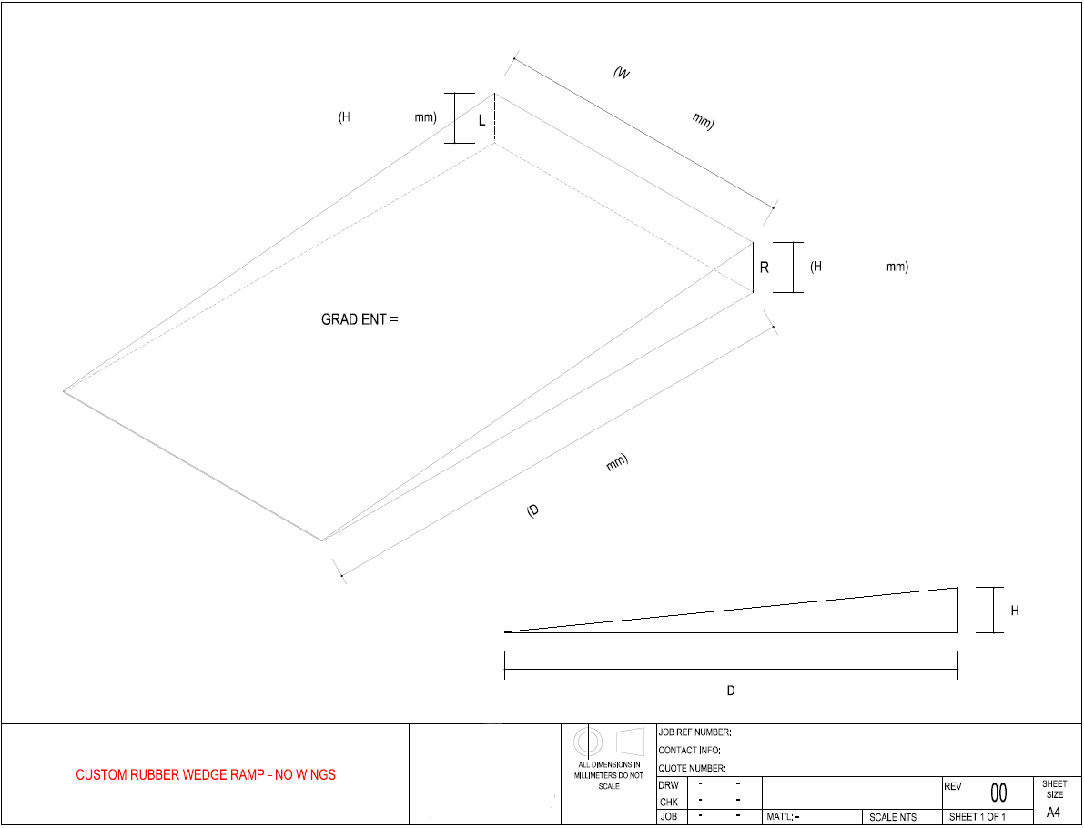

612 Skipton St

Redan Vic 3350

Ph:03 5336 3900

Email: sales@astecservices.net.au